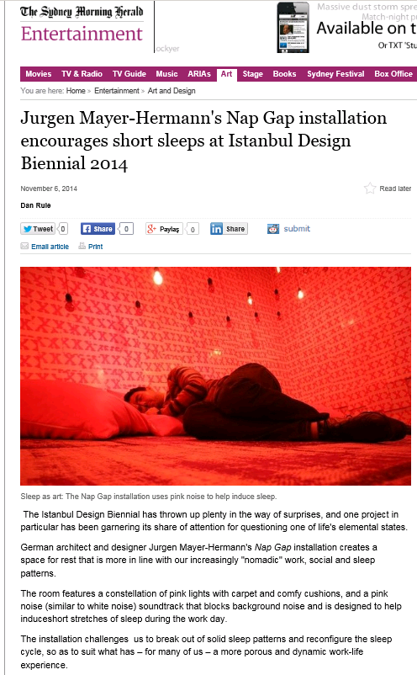C:\Users\medya.stajyer2\AppData\Local\Microsoft\Windows\Temporary Internet Files\Content.Word\Yeni Resim (7).bmp